Project Design Phase-II

# Data Flow Diagram & User Stories

|  |  |
| --- | --- |
| Date | 27 June 2025 |
| Team ID | LTVIP2025TMID30362 |
| Project Name | Citizen AI – Intelligent Citizen Engagement Platform |
| Maximum Marks | 4 Marks |

## Data Flow Diagram (DFD)

A Data Flow Diagram (DFD) is a traditional visual representation of the information flows within a system. It shows how data enters and leaves the system, what changes the information, and where data is stored.

**Context-Level DFD – Citizen AI**

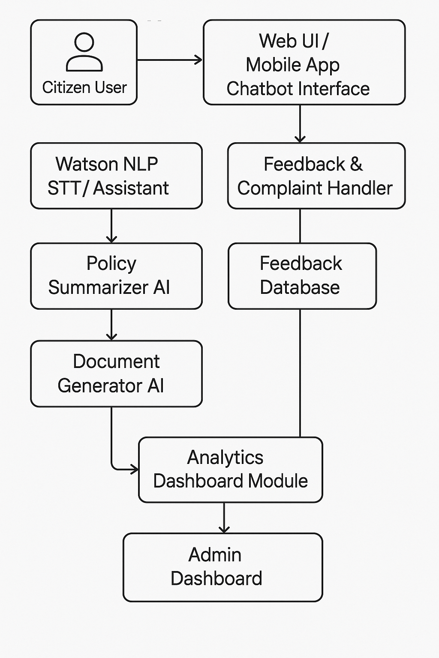

## User Stories

Use this template to list all the user stories for the product.

|  |  |  |  |  |  |
| --- | --- | --- | --- | --- | --- |
| **User Type** | **Functional Requirement (Epic)** | **User Story Number** | **User Story / Task** | **Acceptance Criteria** | **Priority / Release** |
| Citizen (Mobile/Web) | Registration | USN-1 | As a citizen, I can register using my mobile number and Aadhaar for identity verification. | Registration successful, OTP verified | High / Sprint-1 |
| Citizen | Feedback Submission | USN-2 | As a citizen, I can submit feedback or complaints via chatbot or app. | Feedback stored, acknowledgement received | High / Sprint-1 |
| Citizen | Service Guide | USN-3 | As a citizen, I can view available government services relevant to my region. | Service list displays based on location | Medium / Sprint-2 |
| Citizen | AI Assistant Interaction | USN-4 | As a citizen, I can ask questions about policies and get AI-generated summaries. | AI responds accurately with summary and source | High / Sprint-1 |
| Citizen | Document Access | USN-5 | As a citizen, I can download policy documents or certificates generated by AI. | Documents are downloadable in PDF format | Medium / Sprint-2 |
| Customer Care Executive | Query Review | USN-6 | As a customer care exec, I can view citizen queries and status. | Can filter, sort, and view query history | Medium / Sprint-2 |
| Administrator | Analytics Monitoring | USN-7 | As an admin, I can view statistics of user interaction and issue trends. | Analytics dashboard loads with real-time data | High / Sprint-3 |
| Administrator | Content Management | USN-8 | As an admin, I can update policy information and chatbot responses. | Updated content reflected in the user interface | Medium / Sprint-3 |